TEAM ID -- PNT2022TMID07389

TITLE – Personal Assistance For Seniors Who Are Self Reliant

Name – M Yaswanth

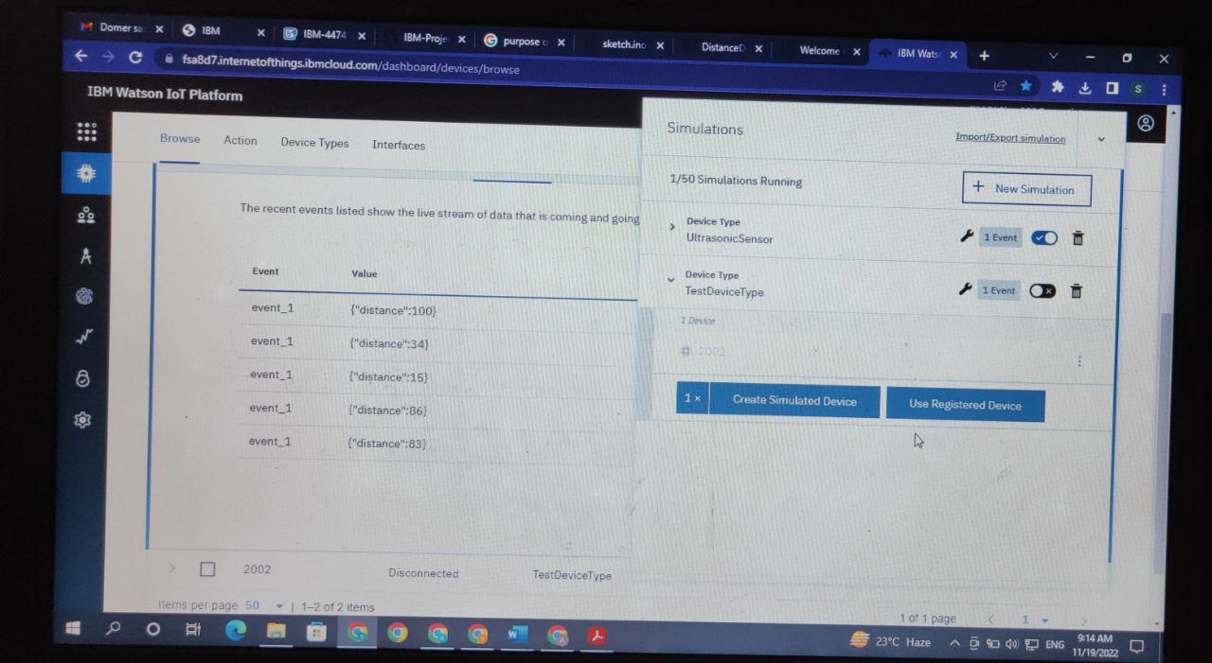

Code:

#include <WiFi.h>//library for wifi

#include <PubSubClient.h>//library for MQtt

#include "HCSR04.h"// Library for HCSR04 ultrasonic sensor

#define LED 4

#define TRIG 2

#define ECHO 5

void callback(char* subscribetopic, byte* payload, unsigned int payloadLength);

//-------credentials of IBM Accounts------

#define ORG "snmigt"//IBM ORGANITION ID

#define DEVICE_TYPE "NodeMCU"//Device type mentioned in ibm watson IOT Platform

#define DEVICE_ID "6789"//Device ID mentioned in ibm watson IOT Platform

#define TOKEN "Yaswanth_M" //Token

String data3;

float d;

//-------- Customise the above values --------

char server[] = ORG ".messaging.internetofthings.ibmcloud.com";// Server Name

char publishTopic[] = "iot-2/evt/Data/fmt/json";// topic name and type of event perform and format in which data to be send

char subscribetopic[] = "iot-2/cmd/test/fmt/String";// cmd REPRESENT command type AND COMMAND IS TEST OF FORMAT STRING

char authMethod[] = "use-token-auth";// authentication method

char token[] = TOKEN;

char clientId[] = "d:" ORG ":" DEVICE_TYPE ":" DEVICE_ID;//client id

//-----------------------------------------

WiFiClient wifiClient; // creating the instance for wificlient

PubSubClient client(server, 1883, callback ,wifiClient); //calling the predefined client id by passing parameter like server id,portand wificredential

int trig=2;

int echo=5;

int led=4;

void setup()

{

Serial.begin(9600);

pinMode(trig,OUTPUT);

pinMode(echo,INPUT);

pinMode(led,OUTPUT);

wificonnect();

mqttconnect();

}

void loop()

{

digitalWrite(trig,LOW);

digitalWrite(trig,HIGH);

delayMicroseconds(10);

digitalWrite(trig,LOW);

float dur=pulseIn(echo,HIGH);

float dist=(dur*0.0343)/2;

Serial.print("distance in cm");

Serial.println(dist);

if(dist>=100)

{

digitalWrite(led,HIGH);

}

else

{

digitalWrite(led,LOW);

}

PublishData(dist);

delay(1000);

if (!client.loop()){

mqttconnect();

}

}

/*.....................................retrieving to Cloud...............................*/

void PublishData(float dist) {

mqttconnect();//function call for connecting to ibm

/*

creating the String in in form JSon to update the data to ibm cloud

*/

String payload = "{\"distance\":";

payload += dist;

Serial.print("Sending payload: ");

Serial.println(payload);

if (client.publish(publishTopic, (char*) payload.c_str())) {

Serial.println("Publish ok");// if it sucessfully upload data on the cloud then it will print publish ok in Serial monitor or else it will print publish failed

} else {

Serial.println("Publish failed");

}

}

void mqttconnect() {

if (!client.connected()) {

Serial.print("Reconnecting client to ");

Serial.println(server);

while (!!!client.connect(clientId, authMethod, token)) {

Serial.print(".");

delay(500);

}

initManagedDevice();

Serial.println();

}

}

void wificonnect() //function defination for wificonnect

{

Serial.println();

Serial.print("Connecting to ");

WiFi.begin("Wokwi-GUEST", "", 6);//passing the wifi credentials to establish the connection

while (WiFi.status() != WL_CONNECTED) {

delay(500);

Serial.print(".");

}

Serial.println("");

Serial.println("WiFi connected");

Serial.println("IP address: ");

Serial.println(WiFi.localIP());

}

void initManagedDevice() {

if (client.subscribe(subscribetopic)) {

Serial.println((subscribetopic));

Serial.println("subscribe to cmd OK");

} else {

Serial.println("subscribe to cmd FAILED");

}

}

void callback(char* subscribetopic, byte* payload, unsigned int payloadLength)

{

Serial.print("callback invoked for topic: ");

Serial.println(subscribetopic);

for (int i = 0; i < payloadLength; i++) {

//Serial.print((char)payload[i]);

data3 += (char)payload[i];

}

Serial.println("data: "+ data3);

if(data3=="lighton")

{

Serial.println(data3);

digitalWrite(LED,HIGH);

}

else

{

Serial.println(data3);

digitalWrite(LED,LOW);

}

data3="";

}

